1. INTRODUCTION & OBJECTIVES
Database Interface is an industry-standard tool for application development. Using Database Interface, developers can interact with any back end software (i.e. Oracle, MS-SQL Server, MS-Access, My-SQL etc). The database interface can be used to build, test, and debug PL/SQL packages, procedures, triggers, and functions. Database Interface users can create and edit database objects such as tables, views, indexes, constraints, and users. Database Interface's SQL Editor provides an easy and efficient way to write and test scripts and queries, and its powerful data grids provide an easy way to view and edit data related to any DBMS/RDBMS tool.
The requirements of a database application developer will vary from project to project. On a large team where DBAs manage the DDL, a developer may spend 90% of development time coding and testing SELECT queries to issue from 3GL or 4GL application code. In such an environment, a developer might be concerned only with viewing the DDL and database code. On smaller teams, a developer might be responsible for maintenance of the development schema, movement of test data between schemas, writing procedure code, populating tables from legacy sources, and more. Database Interface facilitates all of these needs.
For example if you are working with oracle, you don't have to be a PL/SQL expert to access database objects with Database Interface. You can view the Oracle Dictionary, tables, indexes, stored procedures, and more - all through a multi-tabbed browser. Database Interface utilizes direct Oracle OCI calls for full access to the Oracle API.
Advanced editing features save time and increase productivity. Code can be created from shortcuts and code templates. You can even create your own code templates.

Use Database Interface to
- Create, browse, or alter objects (tables, views, indexes, etc.) including Oracle8 TYPE objects
- Graphically build, execute, and tune queries
- Edit and Debug PL/SQL and profile "stored procedures" including functions, packages, and triggers
- Search for objects
- Find and fix database problems with constraints, triggers, extents, indexes, and grants

Project Advantages:
- Flexibility. The end-user should be able to use any major commercial (or open-source) database on the market. Moreover, the end-user should be able to customize the look-and-feel of the front-end; this includes the ability to internationalize the application.
- Maintenance. Both external documentation (like this) and inline java docs should explain how things work. I've tried to write clean Java code so that developers who build on database interface will have a clear, easily extensible starting point.
- Ease of Use. Installation is simple; you just have to create a .war file and drop it in the right directory/folder. The Java search engine interface is text-based, and intended to provide easy access to search operations.

2.i. IDENTIFICATION OF NEED
To clearly identify the need of this application, I will try to exemplify one situation.
A project manager is dealing with an enterprise application, which is in the development phase. This application has got different faces such as a desktop interface, a web interface and mobile interface. Initially all these applications are not integrated. Once these entire interfaces are working well, they are going to be integrated. In such occasion the database which is being used must be same. But while designing these individual modules, creating a sample database for each module and perform the test, it is not possible practically. So for that reason, there must be a kind of tool, using which we can carry the database to any another location and use the database there very easily.
The present application will fulfill the requirement. The current application can be used just as a brief case of database.

2.ii. PRELIMINARY INVESTIGATION
The present application can be differentiated into the following modules, which are closely integrated with one another.
- Structure: It gives the list of all tables which are present in the current/selected user. This module is used to browse and view the structure of an existing database object.
- Properties: The properties module enables us to modify data types, size and constraints assigned to each field.
- SQL: Using this module, we can use and implement different kinds of SQL statements. The result of the SQL statement will be displayed immediately after executing the statement.
- Import: This module gives an exclusive feature of importing the existing SQL scripts to the existing schema.
- Export: This module gives the feature of exporting existing schema object(s) to an SQL file. Here the facility is there to export only tables, only single user or the entire schema.
- Operations: This module will be used to create new database objects.
- Search: Search module provides searching facilities for searching for the given column names, data or both options.

3. FEASIBILITY STUDY
All projects are feasible – given unlimited resources and infinite time! Unfortunately, the development of computer-based system or product is more likely plagued by a scarcity of resources and difficult delivery dates. It is both necessary and prudent to evaluate the feasibility of a project at the earliest possible time. Months or years of effort, thousands or millions of dollars, and untold professional embarrassment can be averted if an ill-conceived system is recognized early in the definition phase.

Feasibility and risk analysis are related in many ways. If project risk is great the feasibility of producing quality software is reduced. During product engineering, however, we concentrate our attention on four primary areas of interest:

Technical Feasibility
This application in going to be used in an Internet environment called www (World wide web). So, it is necessary to use a technology that is capable of providing the networking facility to the application. We can deploy and used it in any operating system.
GUI is developed using HTML to capture the information from the customer. HTML is used to display the content on the browser. It uses TCP/IP protocol. It is an interpreted language. It is very easy to develop a page/document using HTML some RAD (Rapid Application Development) tools are provided to quickly design/develop our application. So many objects such as button, text fields, and text area etc are provide to capture the information from the customer.
We can use this application in any OS. They can have their own security and transactional advantages. But are the responsible for selecting suitable and secured OS, which is suitable to our application.
Economical Feasibility
Economic analysis is the most frequently used technique for evaluating the effectiveness of a proposed system. It is more commonly known as cost/benefit analysis. The procedure is to determine the benefits and savings that are expected from a proposed system and compare them with costs. If benefits outweigh cost, a decision is taken to design and implement the system. Otherwise, further justification or alternative in the proposed system will have to be made if it is to have a chance of being approved.
Automation system that is developed technically and that is used on installation is good investment for organization. The financial benefit must equal or exceed that cost. The amount being spent on system study, processing hardware, developing software is reasonable considering the loss of revenue owing to the prevailing loopholes in the system. Benefits in the form of reduced costs like client side with minimum configuration, system compatibility of any hardware and timing effective manner of allocating systems and registering complaints.
Operational Feasibility:
In our application front end is developed using GUI. So it is very easy to the customer to enter the necessary information. But customer has some knowledge on using web applications before going to use our application.

4. SOFTWARE ENGINEERING PARADIGM APPLIED
DESIGN SPECIFICATION
Design of software involves conceiving planning out and specifying the externally observable characteristics of the software product. We have data design, architectural design and user interface design in the design process. These are explained in the following section. The goals of design process it to provide a blue print for implementation, testing, and maintenance activities.

DATA DESIGN
The primary activity during data design is to select logical representations of data objects identified during requirement analysis and software analysis. A data dictionary explicitly on the elements of the data structure. A data dictionary should be established and used to define both data and program design.

DESIGN METHODOLOGY
The two basic modern design strategies employed in software design are
- Top Down Design
- Bottom Up Design
Top Down Design is basically a decomposition process, which focuses on the flow of control. At later stages it concern itself with the code production. The first step is to study the overall aspects of the tasks at hand and to break it into a number of independent modules. The second step is to break each one of these modules further into independent sub-modules. The process is
Repeated one to obtain modules, which are small enough to group mentally and to code in a straightforward manner. One important feature is that at each level the details of the design at the lower level are hidden. Only the necessary data and control that must be called back and forth over the interface are defined.
In a bottom-up design one first identifies and investigates parts of design that are most difficult and necessary designed decision are made the reminder of the design is tailored to fit around the design already chose for crucial part. It vaguely represents a synthesis process explained in previous section.
One storage point of the top-down method is that it postpones details of the decision until the last stage of the decision. It allows making small design changes when the design is half way through. There is danger that the specifications will be incompatible and this will not be discovered until late in the design process. By contrast the bottom-up strategy first focuses on the crucial part so that feasibility of the design is tested at early stage.
In mixing top-down and bottom-up design it often appears that we start in the middle of the problem and work our way both up and down there. In a complex problem, it is often difficult to decide how to modularize the various procedures in such cases one might consider a list of system inputs and decide what functions are necessary to process these inputs. This is called back to front design. Similarly one can start with the required outputs and work backwards evolving so called front-back design. We have applied both the top down and bottom up approach in our design approach.

DATABASE DESIGN
Databases are normally implemented by using a package called a Data Base Management System (DBMS). Each particular DBMS has somewhat unique characteristics, and so such, general techniques for the design of database are limited. One of the most useful methods of analyzing the data required by the system for the data dictionary has developed from research into relational database, particularly the work of E.F.Codd. this method of analyzing data is called “Normalization”. Unnormalized data are converted into normalized data by three stages. Each stage has a procedure to follow.
NORMALIZATION
The first stage is normalization is to reduce the data to its first normal form, by removing repeating items showing them as separate records but including in them the key fields of the original record.
The next stage of reduction to the second normal form is to check that the record, which one is first normal form, all the items in each record are entirely dependent on the key of the record. If a data item is not dependent on the key of the record, but on the other data item, then it is removed with its key to form another record. This is done until each record contains data items, which are entirely dependent on the key of their record.
The final stage of the analysis, the reduction of third normal form involves examining each record, which one is in second normal form to see whether any items are mutually dependent. If there are any item there are removed to a separate record leaving one of the items behind in the original record and using that as the key in the newly created record.
BUSINESS MODELING:
The information flow among business function is modeled in a way that answers the following questions: what information drives the business process? What information is generated? What generate it? Where does the information go? Who process it?
DATA MODELING:
The information flow defined as a process of the business modeling is refined into a set of data objects that are needed to support the business. The characteristics 9called attributes0 of each object are identified and relationships between these objects are defined.
PROCESS MODELING:
The data objects defined in the data-modeling phase are transformed to achieve the information flow necessary to implement a business function. Processing description are created for addition, modifying, deleting, or retrieving a data object.
THE LINEAR SEQUENTIAL MODEL:
The linear sequential model for software engineering some times called the “classic model” or the “water fall model,” the linear sequential suggests a systematic, sequential approach to software development that begins at eth system level and process through analysis, design, coding, testing, and maintenance.
The linear sequential model is the oldest and the most widely used paradigm for software engineering. Modeled after the conventional engineering cycle, the linear sequential model encompasses the following activities:
1) SYSTEM/INFORMATION ENGINEERING AND MODELLING:
- Because software is always part of a larger system (or business), work begins by establishing requirements for all system elements and then allocating some subset of these requirements to software. This system view is essential when software must interface with other elements such as hardware, people, and databases.
- System engineering and analysis encompasses requirements gathering at the system level with a small amount of top-level analysis and design. Information engineering encompasses requirements gathering at the strategic business level and at the strategic business level and at the business area level.
2) SOFTWARE REQUIREMENTS ANALYSIS:
- The requirements gathering process is intensified and focused specifically on software. To understand the nature of the programs to be built, the software Engineer must under stand the information domain for the software, as well as required function, behavior, performance, and inter facing. Requirements for the both the system and the software are documented and reviewed with the customer.
3) DESIGN:
- Software design is actually a multi step process that focuses on four distinct attributes of a program: data structure, software architecture, interface representations, and procedural detail. The design process translates requirements into a representation of the software that can be assessed for quality before code generation begins. Like requirements the design is documented and becomes part of the software configuration.
4) CODE GENERATION:
- The design must be translated into a machine-readable form. The code generation step performs this task. If design is performed in a detailed manner, code generation can be accomplished mechanistically.
5) TESTING:
- Once code has been generated, program testing process focuses on the logical internals of the software, assuring that all statements have been tested, and on the functional externals that is, conducting tests to uncover errors and ensure that defined input will produce actual results that agree with required results.
6) MAINTENANCE:
- Software will undoubtedly undergo change after it is delivered to the customer. Change will occur because errors have been encountered, because the software must be adapted to accommodate changes in its external environment (e.g., a change required because of a new operating system or peripheral devices), or because the customer requires functional or performance enhancement. Software maintenance reapplies each of the preceding phases to an existing program rather than a new one
.

.
5. SOFTWARE AND HARDWARE SPECIFICATIONS
The following hardware using for developing the project

(i) Hardware requirement for developing
- Pentium III Processor with @ 800 Mhz Speed
- 128 RAM
- 10 GB HDD
- 14” Color Monitor
- 1.44 MB FDD
- CD ROM drive
- 105 keys keyboard
- 4 Serial + 4 Parallel ports
- Mouse
- Printer
- Ethernet card
- Internet Modem
- Software requirement for developing
- Windows 2000 Operating system
- J2SE 1.4
- Tomcat Web Server 5.0.25

INTERNET TERMINOLOGY

What is Internet?
The Internet is a worldwide network of computer networks. People use the Internet to send electronic mail, participate in discussion forums, search authority that controls or regulates the Internet Currently there are more than 30 million people use the Internet and the number is growing at a rate of one million new user per month.
What is Intranet?
An internal network owned and managed by a company or organization uses the same kinds of software that you would use to explore the Internet, but only for internal use. An Internet enables a company to share its resources with it employees without confidential information being made available to everyone with Internet access.

What is web Browser?
A web browser is a program run on a client workstation used to navigate the World Wide Web.

What is WWW (World Wide Web)?
WWW is a collection of resources (make up of Hypertext, graphics, sound files, etc) located on globally networked web/internet servers that can be accessed on the Internet by using HTTP, FTP, Telnet, Gopher and some other tools.
What is TCP-IP?
This is the suite of protocols that defines the Internet. Originally designed for the Unix Operating system. TCP/IP software is now available for every major kind of computer operating system. TCP/IP stacks is required for computers want to access the Internet.
What is URL (Uniform Resource Locator)?
The standard way to give the address of any resource on the Internet that is part of the World Wide Web (WWW). A URL looks like this:
The most common way to use a URL is to enter into a WWW browser program, such as Internet Explorer.
Java and Java Script:
Although the names are almost the same Java is not the same as Java Script. These are two different techniques for Internet programming. Java is a programming language; JavaScript is a scripting language (as the name implies). The difference is that we can create real programs with Java. But often we just want to make a nice effect without having to bother about real programming. So JavaScript is meant to be easy to understand and easy to use. JavaScript authors should not have to care too much about programming.
We could say that JavaScript is rather an extension to HTML than a separate computer language. Of course this is not the ‘official’ definition but I think this makes it easier to understand the difference between Java and JavaScript, which share the same name and syntax.
Advantages of Java:
Creation of Java:
James Gosling conceived Java. Patrick Naughton, Chris Warth, Ed Frank and Mike Sheridan at Sun Micro Systems Incorporation in 1991. It took 18 months to develop the first working version. This language was initially called “OAK” in 1992 and public announcement of Java in 1995, many more contributed to the design and evolution of the language.
Java is Portable:
One of the biggest advantages Java offers is that it is portable. An application written in Java will run on all the major platforms. Any computer with a Java based browser can run the applications or applets written in the Java programming language. A programmer no longer has to write one program to run on a Macintosh, another program to run on a Windows machine, still another to run on a Unix machine and so on. In other words, with Java, developers write their programs only once.
The virtual machine is what gives Java a cross platform capabilities. Rather than being complied into machine language, which is different for each operating systems and computer architecture, Java code is compiled into byte codes. With other languages, the program code is complied into a language that the computer can understand. The problem is that other computers with different machine instruction set cannot understand that language. Java code, on the other hand is complied into byte codes rather than a machine language. These byte codes go to the Java virtual machine, which executes them directly or translates them into the language that is understood by the machine running it.
In summary, these means that with the JDBC API extending Java, a programmer writing Java code can access all the major relational databases on any platform that supports the Java virtual machine.
Java is Object – Oriented:
Java is Object Oriented, which makes program design focus on what you are dealing with rather than on how you are going to do something. This makes it more useful for programming in sophisticated projects because one can break the things down into understandable components. A big benefit is that these components can then be reused.
Object oriented languages use the paradigm of classes. In simplest term, a class includes both the data and the functions to operate on the data. You can create an instance of a class, also called an object, which will have all the data members and functionality of its class. Because of this, you can think of a class as being like template, with each object being a specific instance of a particular type of class.
The class paradigm allows one to encapsulate data so that specific data values are those using the data cannot see function implementation. Encapsulation makes it possible to make the changes in code without breaking other programs that use that code. If for example the implementation of a function is changed, the change is invisible to another programmer who invokes that function, and it does not affect his/her program, except hopefully to improve it.
Java includes inheritance, or that ability to derive new classes from existing classes. The derived class, also called subclass, inherits all the data and the function of the existing class, referred to as the parent class. A subclass can add new data members to those inherited form the parent class. As far as methods are concerned, the subclass can reuse the inherited methods, as it is, or change them, or even add its own new methods.
Java Makes It Easy:
In addition to being portable and object oriented, Java facilitates writing correct code. Programmers spend less time writing Java code and a lot less time debugging it. In fact, developers have reported slashing development time by as much as two thirds.
Java automatically takes care of allocating and the reallocating memory, a huge potential source of errors. If an object is no longer being used (has no reference to it), then it is automatically removed from memory, or Garbage Collected by a low priority daemon thread called Garbage Collector.
Java’s no pointer support eliminates big source errors. By using object references instead of memory pointers, problems with pointer arithmetic are eliminated, and problems with inadvertently accessing the wrong memory address are greatly reduced.
Java’s strong typing cuts down on runtime errors, because Java enforces strong type checking, many errors are caught when code is complied. Dynamic binding is possible and often very useful, but static binding with strict type checking is used when possible.
Java keeps code simple by having just one way to do something instead of having several alternatives, as in some languages. Java also stays lean by not including multiple inheritance, which eliminates the errors and ambiguity that arise when you create a subclass that inherits from two or more classes. To replace capabilities, multiple inheritance provides, Java lets you add functionality to a class throw the use of interfaces.
Java is Extensible:
A big plus for Java is the fact it can be extended. It was purposely written to be lean with the emphasis on doing what it does very well, instead of tying to do everything from the beginning, it was return so that extending it is very easy. The java platform includes an extensive class library so that programmers can use already existing classes, as it is, create subclasses to modify existing classes, or implement to augment the capabilities of classes.
Java is Secure:
It is important that a programmer not be able to write subversive code for applications or applets. This is especially true with the Internet being used more and more extensively for services such as electronic commerce and electronic distribution of software and multimedia content.
The way memory is allocated and laid out. In java an object’s location in memory is not determined until the runtime, as opposed to C and C++. As the result, a programmer cannot look at a class definition and figure out how it might be laid out in memory. Also since, Java has no pointers, a programmer cannot forge pointers to memory.
The Java Virtual Machine (JVM) doesn’t trust any incoming code and subjects it to what is called Byte Code Verification. The byte code verifier, part if the virtual machine, checks that
  - The format of incoming code is correct
  - Incoming code doesn’t forge pointers.
  - It doesn’t violate access restrictions.
  - It access objects as what they are
The Java byte code loader, another part of the JVM, checks whether classes loaded during program execution are local of from across a network. Imported classes cannot be substituted for built in classes, and built in classes cannot accidentally reference classes bring in over a network.
The Java Security manager allows user to restrict entrusted Java applets so that they cannot access the local network, local files and other resources.
Java Performs Well:
Java performance is better than one might expect. Java’s many advantages, such as having built in security and being interpreted as well as complied, do have a cost attached to them. However, various optimizations have been built, in, and the byte code interpreter can run very fast the cost it doesn’t to do any checking. AS a result, Java has done quite respectably in performance tests. Its performance numbers for interpreted byte codes are usually more than adequate to run interactive graphical end user applications.
For situations that require unusually high performance, byte codes can be translated on the fly generating the final machine code for the particular CPU on which the application is running at run time. Java offers good performance with the advantages of high-level languages but without the disadvantages of C and C++. In the world of design trade-off, you can think of Java as providing a very attractive middle ground.
Java is Robust:
The multi plat formed environment of the WEB places extraordinary demands on a program, because it must execute reliably in a variety of systems. Thus the ability to create robust programs was given a high priority in the design of Java. To gain reliability, Java restricts you in a few key areas to force you to find your mistakes early in program developments. At the same time, Java frees you from having to worry about many of the most common causes of programming errors. Because Java is strictly typed language, it checks your code at compile time. However, it also checks your code at run time. In fact, many hard to track down bugs that often turn up in hard to reproduce runtime situations are simply impossible to create in Java. Knowing that what you have written will behave in a predictable way under diverse conditions is a key feature of Java.
Java is Multithreaded:
Multithreading is simply the ability of a program to do more than one thing at a time. For example an application could be faxing a document at the same time it is printing another document. Or a program could process new inventory figures while it maintains a feed for current prices. Multithreading is particularly important in multimedia: a multimedia program might often be running a movie, running a audio track and display in text all at the same time.
Java Scales Well:
Java platform is designed to scale well, from portable consumer electronic devices to powerful desktop and server machines. The virtual machine takes a small footprint and Java byte code is optimized to be small and compact. As a result, Java accommodates the need for low storage and for low bandwidth transmission over the Internet. In the addition the Java operating system offers a standalone Java platform that eliminates host operating system overhead while still supporting the full Java Platform API. This makes Java ideal for low cost network computers whose sole purpose is to access the Internet.
Java and Internet:
The Internet helped catapult Java to the forefront of programming and Java in turn has had a profound effect on the Internet. The reason is simple: Java expands the universe of objects that can move about freely in cyberspace. In a network, there are two broad categories of objects transmitted between the Server and your Personal Computer: passive information and dynamic, active programs like an object that can be transmitted to your computer, which is a dynamic, self-executing program. Such a program would be an active agent ton the client computer, yet the server would initiate it. As desirable as dynamic, networked programs are, they also present serious problems in the areas of security and portability. Prior to Java cyberspace was effectively closed to half the entities that now live there. Java addresses these concerns and doing so, has opened the door to an exiting a new form of program.
The rise of server-side Java applications is one of the latest and most exciting trends in Java programming. It was first hyped as a language for developing elaborate client-side web content in the form of applets. Now, Java is coming into its own as a language ideally suited for server-side development. Businesses in particular have been quick to recognize Java’s potential on the server-Java is inherently suited for large client/server applications. The cross platform nature of Java is extremely useful for organizations that have a heterogeneous collection of servers running various flavors of the Unix of Windows operating systems. Java’s modern, object-oriented, memory-protected design allows developers to cut development cycles and increase reliability. In addition, Java’s built-in support for networking and enterprise API provides access to legacy data, easing the transition from older client/server systems.
Java Servlets are a key component of server-side java development. A Servlets is a small, plug gable extension to a server that enhances the server’s functionality. Servlets allow developers to extend and customize and Java enabled server a web server, a mail server, an application server, or any custom server with a hitherto unknown degree of portability, flexibility and ease.
JAVA SERVER PAGE (JSP):
Java Server Pages is a simple, yet powerful technology for creating and maintaining dynamic-content web pages. Based on the Java programming language, Java Server Pages offers proven portability, open standards, and a mature re-usable component model.
PORTABILITY:
Java Server Pages files can be run on any web server or web-enabled application server that provides support for them. Dubbed the JSP engine, this support involves recognition, translation and management of the Java Server Pages lifecycle and its interaction with associated components.
The JSP engine for a particular server might be built-in or might be provided through a 3rd –party add-on. As long as the server on which you plan to execute the Java Server Pages supports the same specification level as that to which the file was written, no change should be necessary as you move your files from server to server. Note, however, that instructions for the setup and configuration of the files may differ between files.
COMPOSITION:
It was mentioned earlier that the Java Server Pages architecture could include reusable Java components. The architecture also allows for the embedding of a scripting language directly into the Java Server Pages file. The components current supported include Java Beans and Serves. As the default scripting language, Java Server Pages use the Java Programming language. This means that scripting on the server side can take advantage of the full set of capabilities that the Java programming language offers.
PROCESSING:
A Java Server Pages file is essentially an HTML document with JSP scripting or tags. It may have associated components in the form of class, .jar, or .ser files- -or it may not. The use of components is not required.
The Java Server Pages file has a .jsp extension to identify it to the server as a Java Server Pages file. Before the page is served, the Java Server Pages syntax is parsed and processed into a servlet on the server side. The servlet that is generated, outputs real content in straight HTML for responding to the customer. Because it is standard HTML, the dynamically generated response looks no different to the customer browser than a static response.
ACCESS MODELS:
A Java Server Pages file may be accessed in at least two different ways: A client request comes directly into a Java Server Page.

Browser

Bean

JSP
Request
Response

In this scenario, suppose the page accessed reusable Java Bean components that perform particular well-defined computations like accessing a database. The result of the Bean’s computations, called result sets is stored within the Bean as properties. The page uses such Beans to generate dynamic content and present it back to the client. A request comes through a servlet.
SERVLET

Browser

Bean

JSP
Request
Response
Result Bean
JDBC
Database

The servlet generates the dynamic content. To handle the response to the client, the servlet creates a Bean and stores the dynamic content (sometimes called the result set) in the Bean. The servlet then invokes a Java Server Page that will present the content along with the Bean containing the generated from the servlet.
There are two APIs to support this model of request processing using Java Server Pages. One API facilitates passing context between the invoking servlet and the Java Server Page. The other API lets the invoking servlet specify which Java Server Page to use.
In both of the above cases, the page could also contain any valid Java code. The Java Server Pages architecture separation of content from presentation- -it does not mandate it.
JDBC requires that the SQL statements be passed as Strings to Java methods. For example, our application might present a menu of database tasks from which to choose. After a task is selected, the application presents prompts and blanks for filling information needed to carry out the selected task. With the requested input typed in, the application then automatically invokes the necessary commands.
In this project we have implemented three-tier model, commands are sent to a “middle tier” of services, which then send SQL statements to the database. The database process the SQL statements and sends the results back to the middle tier, which then sends them to the user. JDBC is important to allow database access from a Java middle tier.

What Is JDBCTM?
JDBCTM is a JavaTM API for executing SQL statements. (As a point of interest, JDBC is a trademarked name and is not an acronym; nevertheless, JDBC is often thought of as standing for "Java Database Connectivity".) It consists of a set of classes and interfaces written in the Java programming language. JDBC provides a standard API for tool/database developers and makes it possible to write database applications using a pure Java API.
Using JDBC, it is easy to send SQL statements to virtually any relational database. In other words, with the JDBC API, it isn't necessary to write one program to access a Sybase database, another program to access an Oracle database, another program to access an Informix database, and so on. One can write a single program using the JDBC API, and the program will be able to send SQL statements to the appropriate database. And, with an application written in the Java programming language, one also doesn't have to worry about writing different applications to run on different platforms. The combination of Java and JDBC lets a programmer write it once and run it anywhere.
Java being robust, secure, easy to use, easy to understand, and automatically downloadable on a network, is an excellent language basis for database applications. What is needed is a way for Java applications to talk to a variety of different databases. JDBC is the mechanism for doing this.
JDBC extends what can be done in Java. For example, with Java and the JDBC API, it is possible to publish a web page containing an applet that uses information obtained from a remote database. Or an enterprise can use JDBC to connect all its employees (even if they are using a conglomeration of Windows, Macintosh, and UNIX machines) to one or more internal databases via an intranet. With more and more programmers using the Java programming language, the need for easy database access from Java is continuing to grow.
MIS managers like the combination of Java and JDBC because it makes disseminating information easy and economical. Businesses can continue to use their installed databases and access information easily even if it is stored on different database management systems. Development time for new applications is short. Installation and version control are greatly simplified. A programmer can write an application or an update once, put it on the server, and everybody has access to the latest version. And for businesses selling information services, Java and JDBC offer a better way of getting out information updates to external customers.
CONNECTION:
A connection object represents a connection with a database. A connection session includes the SQL statements that are executed and the results that are returned over the connection. A single application can have one or more connections with a single database, or it can have connections with many different databases.

OPENING A CONNECTION:
The standard way to establish a connection with a database is to call the method DriverManager.getConnection. This method takes a string containing a URL. The Driver Manager class, referred to a the JDBC management layer, attempts to locate a driver than can connect to the database represented Driver classes, and when the method get Connection is called, it checks with each driver in the list until it finds one that can connect uses this URL to actually establish the connection.
<Sub protocol>-usually the driver or the database connectivity mechanism, which may be supported by one or more drivers. A prominent example of a sub protocol name is “oracle”, which has been reserved for URLs that specify “thin”-style data source names.
<Sub name>- a way to identify the database. The sub names can vary, depending on the sub protocol, and it can have a sub name with any internal syntax the driver writer chooses. The point of a sub name is to give enough information to locate the database.
SENDING STATEMENT:
Once a connection is established, it is used to pass SQL statements to its underlying database. JDBC does not put any restrictions on the kinds of SQL statements that can be sent; this provides a great deal of flexibility, allowing the use of database-specific statements or even non-SQL statements. It requires, however, that the user be responsible for making sure that the underlying database can process the SQL statements being sent and suffer the consequences if it cannot.
DRIVER MANAGER:
The Driver Manager class is the management layer of JDBC, working between the user and the drivers. It keeps track of the drivers that are available and handles establishing a connection between a database and the appropriate driver. It addition, the driver manager class attends to things like driver login time limits and the printing of log and tracing messages. The only method in this class that a general programmer needs to use directly is DriverManager.getConnection. As its name implies, this method establishes a connection to a database.
ORACLE 8i:
INTRODUCTION TO ORACLE:
Any programming environment used to create containers, to manage human data, in the conceptualization as a Data Management System. Traditionally, the block of human data being managed is called a Database. Hence, in very simple terms, these programming environments can the conceptualized as Database Management Systems, in short DBM systems.
All Databases Management Systems (that is, Oracle is DBMS) allow users to create containers for data stories and management. These containers are called ‘cells’. The minimum information that has to be given to Oracle for a suitable container to be constructed, which can hold free from human data, is,
1. The cell name
2. The cell length
Another name that programming environments use for a ‘Cell’ is ‘Field’. These can the conceptualized as follows.
BASIC DATABASE CONCEPTS:
A database is a corporate collection of data with some inherent meaning, designed, built and populated with data for a specific purpose. A database stores data that is useful to us. This data is only a part of the entire data available in the world around us.
To be able to successfully design and maintain databases we have to do the following:
Identify which part of the world’s data is of interest to us.
Identify what specific objects in that part of the world’s data are of interest to us.
Identify a relationship between the objects.
Hence the objects, their attributes and the relationship between them that are of interest to us are still owed in the database that is designed, built and populated with data for a specific purpose.
CHARACTERISTICS OF A DATABASE MANAGEMENT SYSTEM:
    - It represents a complex relationship between data.
    - Keeps a tight control of debtor redundancy.
    - Enforces user-defined rules to ensure integrity of table data.
    - Has a centralized data dictionary for the storage of information pertaining to data and its manipulation.
    - Ensures that data can be shared across applications.
    - Enforces data access authorization has automatic, intelligent backup and recovery procedures for data.
    - Have different interfaces via which users can manipulate data.
RELATIONAL DATABASE MANAGEMENT:
A relational database management system uses only its relational capabilities to manage the information stored in its databases.
INFORMATION REPRESENTATION:
All information stored in a relational database is represented only by data item values, which are stored in the tables that make up the database. Associations between data items are not logically represented in any other way, such as the use of pointers from one table to the other.
LOGICAL ACCESSIBILITY:
Every data item value stored in relational database is accessible by stating the nature of the table it is stored in, the name of the column under which it is stored and the value of the primary key that defines the row in which it is stored.
REPRESENTATION OF NULL VALUES:
The database management system has a consistent method for representing null values. For example, null values for numeric data must be distinct from zero or any other numeric and for the character data it must be different from a string of blanks or any other character value.
CATALOGUE FACILITIES:
The logical description of the relation database is represented in the same manner as ordinary data. This is done so that the facilities of the relation database management system itself can be used to maintain database description.
DATA LANGUAGE:
The relational database management system may support many types of languages for describing data and accessing the database. However, there must be at least one language that uses ordinary character strings to support the definition of data, the definition of views, the manipulation of data, constraints on data integrity, information concerning authorization and the boundaries for recovery of units.
VIEW UPDATABILITY:
Any view that can be defined using combination of basic tables, that are theoretically updateable, these capital of being updated by the relational database management system.
INSERT, UPDATE AND DELETE:
Any operand that describes the results of a single retrieval operation is capable of being applied to an insert update or delete operation as well.
PHYSICAL DATA INDEPENDENCE:
Changes made to physical storage representation or access methods do not require changes to be made to application programmers.
LOGICAL DATA INDEPENDENCE:
Changes made to tables, that do not modify any data stored in that table, do not require changes to be made to application programmers.
INTEGRITY CONSTRAINTS:
Constraints that apply to entity integrity and referential integrity are specifiable by the data language implemented by the database management system and not by the statements coded into the application program.
DATABASE DISTRIBUTION:
The data language implemented by the relation database management system supports the ability to distribute the database without requiring changes to be made to application programmers. This facility must be provided in the data language, whether or not the database management system itself supports distributed databases.
NON- SUBVERSION:
If the relational database management system supports facilities that allow application programmers to operate on the tables a row at a time, an application programmer using this type access is prevented from by passing entity integrity or referential integrity constraints that are defined for the database.

6. SYSTEM DESIGN

6. i. UML ANALYSIS

UML-diagrams

Use-case-diagram

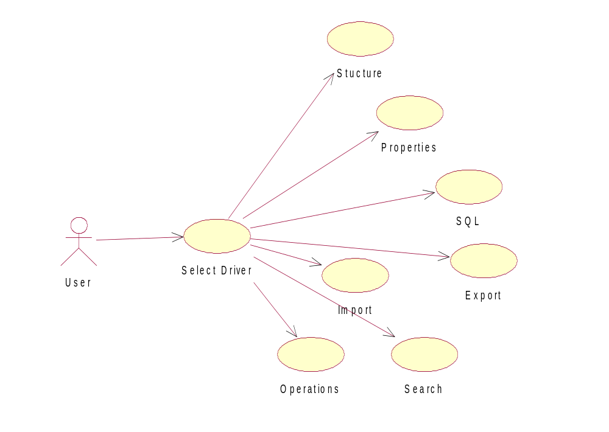

Sequential-diagram

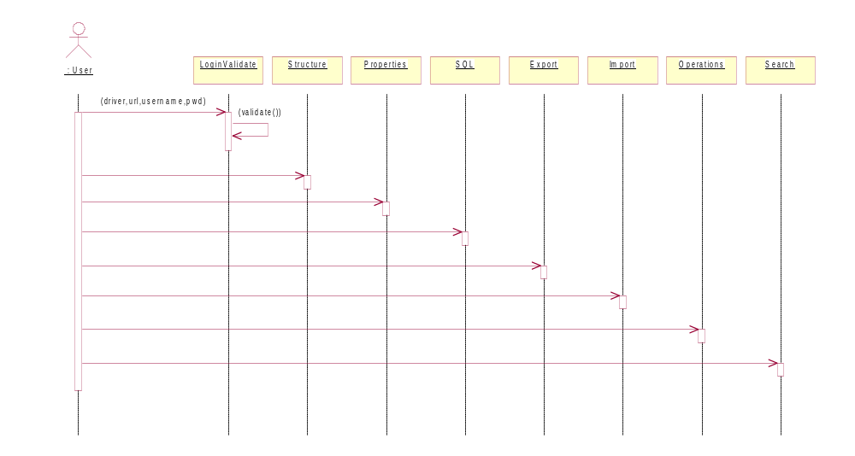

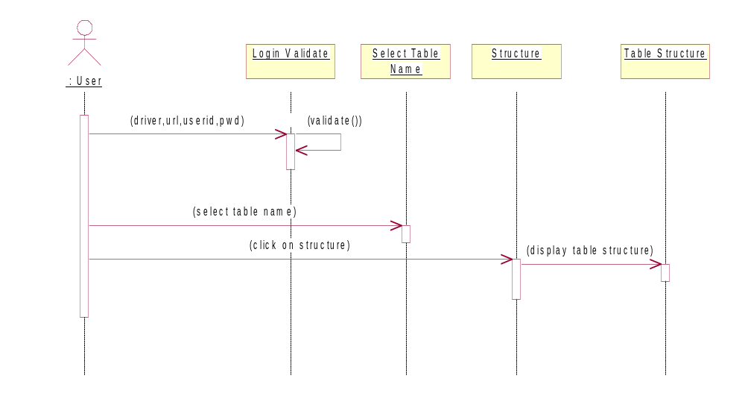

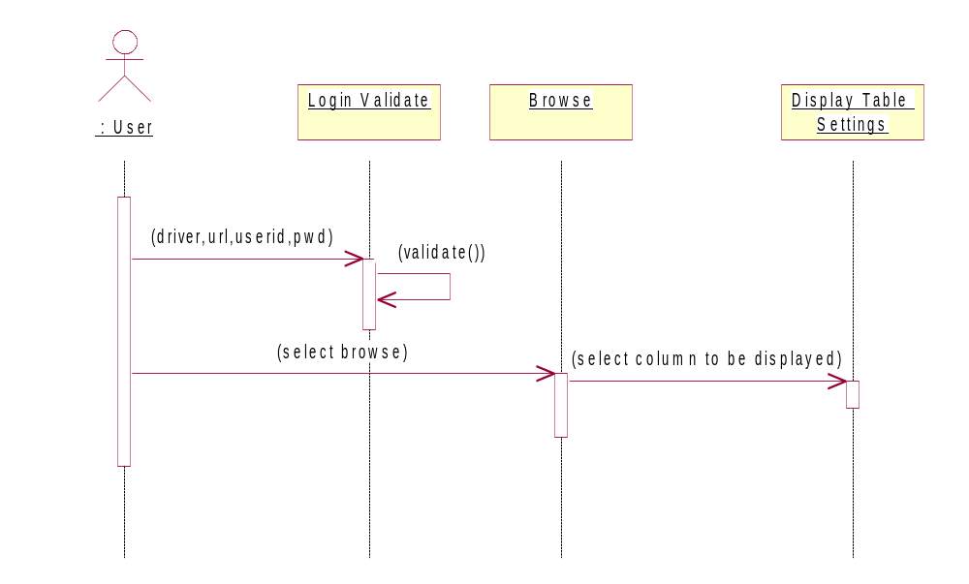

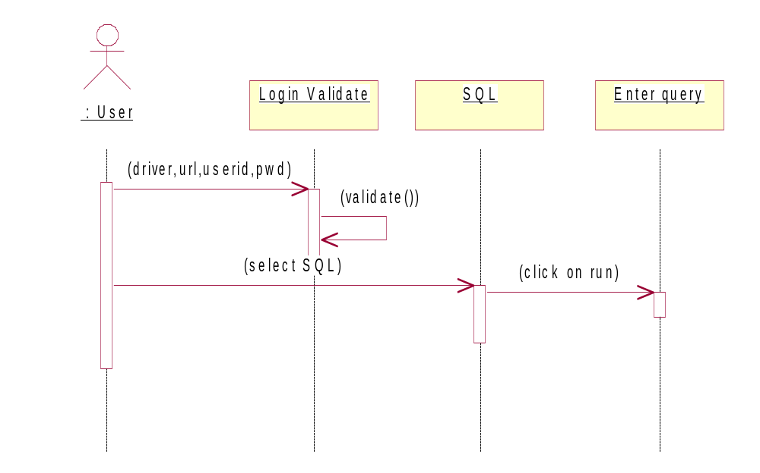

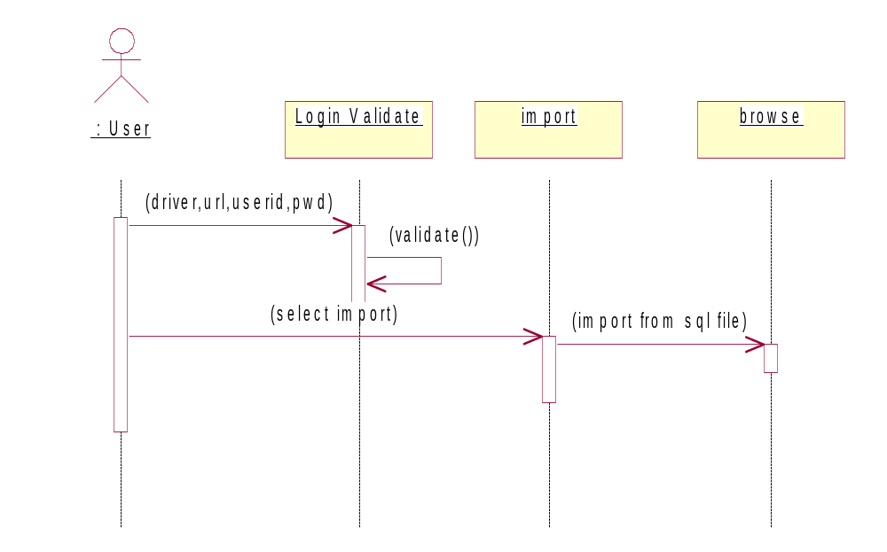
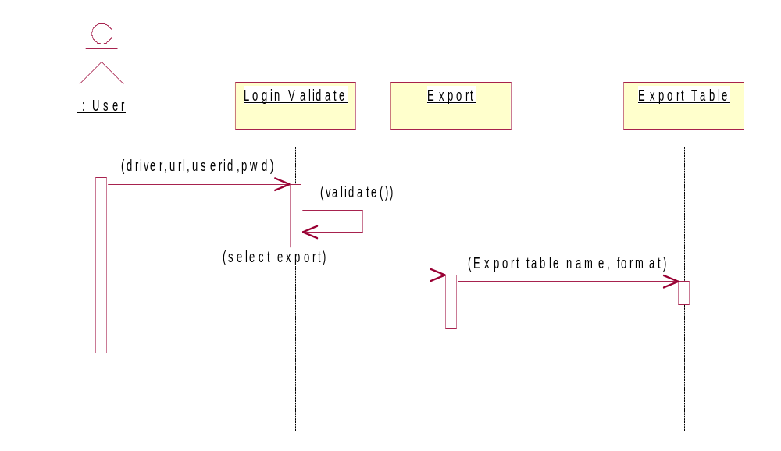

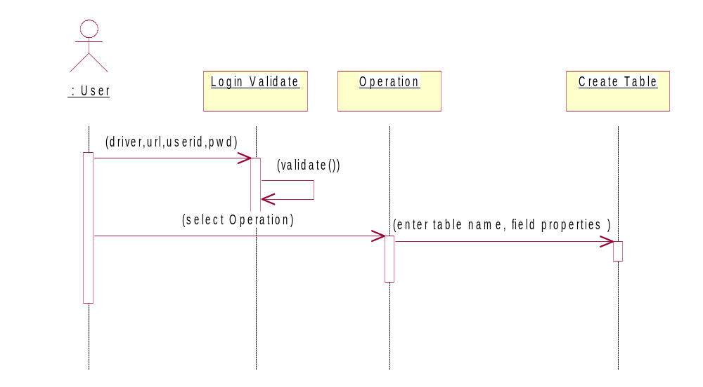

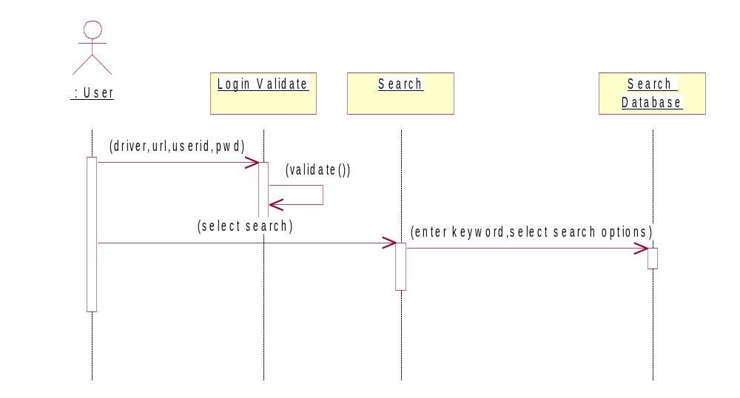

Class –diagram
DataManipulator
Edit Form
Create Tab
Renametab
InputScreen
Report
Menu
GUIComponent
Empty column
DataStore
Desc tab

Browse Form

List DB

<<instantiates>>
<<uses>>
Options
DBOperations

State-diagram

unauthenticated
validation
authenticated
( id,pwd )
( ok )
( id,pwd )

unauthenticated
Validation
DB Menu
( Driver,username,pwd)
( invalid )
( valid )

8. CODE EFFICIENCY

MEASURES OF CODE EFFICIENCY
The code is designed with the following characteristics in mind.
- Uniqueness: The code structure must ensure that only one value of the code with a single meaning is correctly applied to a give entity or attribute.
- Expandability: The code structure are designed for in a way that it must allow for growth of it’s set of entities or attributes, thus providing sufficient space for the entry of new items with in each classification.
- Conciseness: The code requires the fewest possible number of positions to include and define each item.
- Uniform size and format: Uniform size and format is highly desirable in mechanized data processing system. The addition of prefixes and suffixes to the root code should not be allowed especially as it is incompatible with the uniqueness requirement.
- Simplicity: The codes are designed in a simple manner to understand and simple to apply.
- Versatility: The code allows modifying easily to reflect necessary changes in conditions, characteristics and relationship of the encoded entities. Such changes must result in a corresponding change in the code or coding structure.
- Sortability: Reports are most valuable for user efficiency when sorted and presented in a predetermined format or order. Although data must be sorted and collaged, the representative code for the date does not need to be in a sortable form if it can be correlated with another code that is sortable.
- Stability: Codes that do not require to be frequently updated also promote use efficiency. Individual code assignments for a given entity should be made with a minimal likelihood of change either in the specific code or in the entire coding structure.
- Meaningfulness: Code is meaningful. Code value should reflect the characteristics of the coded entities, such as mnemonic features unless such a procedures results in inconsistency and inflexibility.
- Operability: The code is adequate for present and anticipated data processing both for machine and human use. Care is taken to minimize the clerical effort and computer time required for continuing the operation.

9. CODE OPTIMIZATION

Introduction:

A good program is not the one that solves the intended problem alone but the one that does it efficiently. An ideal compiler should produce target code that is as good as can be written by hand crafted meticulously to run on the target machine in the most efficient manner both in terms of time of execution and memory requirements. The reality however is that this goal is achieved only in limited, cases and that too with difficulty. Nonetheless, the code produced by straight forward compiling algorithms can often be made more space and time efficient. This is accomplished by applying transformations on the produced code. These transformations aiming at optimization of compiled code are known as code optimization and compilers that apply code improving transformations are called optimizing compilers.
The optimization may be machine dependent or machine independent. A machine independent optimization is a set of program transformations that improve the target code without taking into consideration any properties of the target machine. Machine dependent optimizations, such as register allocation and utilization of special machine instruction sequences, on the other hand, depend on the target machine.
The overall performance of a program can be effectively improved if we can identify the frequently executed parts of a program and then make these parts as efficient as much as possible. According to Pareto principle, most programs spend ninety per cent of their execution time in ten percent of the code. While the actual percentages may vary, it is often the case that a small fraction of a program accounts for most of the running time. Profiling the run-time execution of a program on representative input data accurately identifies the heavily traveled regions of a program. Unfortunately, a compiler does not have the benefit of sample input data, so it must make best guess as to where the program hot spots are.
In practice, the program's inner loops are good candidates for improvement. In a language that emphasizes control constructs like while and for statements, the loops may be evident from the syntax of the program; in general, a process called contra/flow analysis identifies loops in the flow graph of a program.
The best technique for deciding what transformations are worthwhile to put into a compiler is to collect statistics about the source programs and evaluate the benefit of a given set of optimizations on a representative sample of real source programs.
Organization for an optimizing compiler
There are often levels at which a program can be improved algorithm level, source program level, intermediate level or target level. Since the techniques needed to analyze and transform a program do not change significantly with the level, this chapter concentrates on the transformation of intermediate code using the organization shown below:
In the code optimizer programs are represented by flow graphs, in which edges indicate the flow of control and nodes represent basic blocks. Unless otherwise specified a program means a single procedure.

Sources of Optimization
Let us see some of the most useful code-improving transformations. If looking only at can perform it the statements in a basic block are called local otherwise, it is called global. Many transformations can be performed at both the local and global levels. Local transformations are usually performed first.

Function-preserving Transformations
There are a number of ways in which a compiler can improve a program without changing the function it computes. Common sub-expression elimination, copy propagation, dead code elimination, and constant folding are common examples of such function-preserving transformations.
Frequently, a program will include several calculations of the same value, such as an offset in an array. The programmer cannot avoid some of these duplicate calculations because they lie below the level of detail accessible within the source language.

Common sub-expressions
An occurrence of an expression E is called a common sub-expression if E was previously computed, and the values of variables in E have not changed since the previous computation. We can avoid recomputing the expression if we can use the previously computed value. Removing such command sub-expressions may optimize the code.

COPY PROPAGATION
The idea behind the copy-propagation transformation is to use g for f, wherever possible after the copy statement f: =g.

Dead-Code
A variable is live at a point in a program if its value can be used subsequently; otherwise, it is dead at that point. A related idea is dead or useless code, statements that compute values that never get used. While the programmer is unlikely to introduce any dead code intentionally, it may appear as the result of previous transformations. Deducing at compile time that the value of an expression is a constant and using the constant instead is known as constant folding.

LOOP OPTIMIZATIONS
Loops are very important place for optimizations where programs tend to spend the bulk of their time. If we decrease the number of instructions in an inner loop, even if we increase the amount of code outside that loop, the running time of a program may be improved considerably. Three important techniques for loop optimization are - code motion, which moves code outside a loop; induction-variable elimination, which we apply to eliminate loop indices from the inner loops; and reduction in strength, which replaces an expensive operation by a cheaper one, such as a multiplication by an addition. Some of the loop optimization techniques are discussed below:

Code Motion
Code motion is an important modification that decreases the amount of code in a loop. It takes an expression and transforms it yielding the same result independent of the number of times a loop is executed (i.e. a loop-invariant computation) and places the expression before the loop. The assumption made here is that an entry for the loop exists. For instance, evaluation of a loop-invariant computation in the following while-statement:
Clearly the code motion technique has reduced the number of computations in this form.

Induction Variables And Reduction In Strength
Code motion may not be applicable to all the situations. Loops are usually processed from inside to outside. For example, consider the following loops:
Note that the values of j and t2 remain in lock step; every time the value of j decreases by 1, that of t2 decreases by 5 because 5* j is assigned to t2. Such identifiers are called induction variables.
By the process of induction variable elimination in a loop, it may be possible to get rid of all but one when more than one induction variables are present.

Basic Blocks Optimization
Many of the structure-preserving transformations can be implemented by constructing a directed-cyclic-graph (DAG) for a basic block. There is a node in the DAG for each of the initial values of the variables appearing in the basic block, and there is a node n associated with each statement s within the block. The children of n are those nodes corresponding to statements that are the last definitions prior to s of the operands used by s. Node n is labeled by the operator applied at s, and also attached to n is the list of variables for which it is the definition within the block. We also note those nodes, if any, whose are live on exit from the block; these are the output nodes.

11. SYSTEM TESTING & IMPLEMENTATION

SOFTWARE TESTING TECHNIQUES:

Software testing is a critical element of software quality assurance and represents the ultimate review of specification, designing and coding.

TESTING OBJECTIVES:

- Testing is process of executing a program with the intent of finding an error.
- A good test case design is one that has a probability of finding an as yet undiscovered error.
- A successful test is one that uncovers an as yet undiscovered error.

These above objectives imply a dramatic change in view port.
Testing cannot show the absence of defects, it can only show that software errors are present.

TEST CASE DESIGN:

Any engineering product can be tested in one of two ways:
- White Box Testing: This testing is also called as glass box testing. In this testing, by knowing the specified function that a product has been designed to perform test can be conducted that demonstrates each function is fully operation at the same time searching for errors in each function. It is a test case design method that uses the control structure of the procedural design to derive test cases. Basis path testing is a white box testing.
Basis Path Testing:
- Flow graph notation
- Cyclomatic Complexity
- Deriving test cases
- Graph matrices
Control Structure Testing:
- Condition testing
- Data flow testing
- Loop testing

- Black Box Testing: In this testing by knowing the internal operation of a product, tests can be conducted to ensure that “ all gears mesh”, that is the internal operation performs according to specification and all internal components have been adequately exercised. It fundamentally focuses on the functional requirements of the software.

The steps involved in black box test case design are:
- Graph based testing methods
- Equivalence partitioning
- Boundary value analysis
- Comparison testing

SOFTWARE TESTING STRATEGIES:

A software testing strategy provides a road map for the software developer. Testing is a set of activities that can be planned in advance and conducted systematically. For this reason a template for software testing a set of steps into which we can place specific test case design methods should be defined for software engineering process. Any software testing strategy should have the following characteristics:
- Testing begins at the module level and works “outward” toward the integration of the entire computer based system.
- Different testing techniques are appropriate at different points in time.
- The developer of the software and an independent test group conducts testing.
- Testing and Debugging are different activities but debugging must be accommodated in any testing strategy.

Unit Testing: Unit testing focuses verification efforts in smallest unit of software design (module).

- Unit test considerations
- Unit test procedures

Integration Testing: Integration testing is a systematic technique for constructing the program structure while conducting tests to uncover errors associated with interfacing. There are two types of integration testing:
- Top-Down Integration: Top down integration is an incremental approach to construction of program structures. Modules are integrated by moving down wards throw the control hierarchy beginning with the main control module.

- Bottom-Up Integration: Bottom up integration as its name implies, begins construction and testing with automatic modules.

- Regression Testing: In this contest of an integration test strategy, regression testing is the re execution of some subset of test that have already been conducted to ensure that changes have not propagate unintended side effects.
VALIDATION TESTING:
At the culmination of integration testing, software is completely assembled as a package; interfacing errors have been uncovered and corrected, and a final series of software tests – validation testing – may begin. Validation can be fined in many ways, but a simple definition is that validation succeeds when software functions in a manner that can be reasonably expected by the customer.
Reasonable expectation is defined in the software requirement specification – a document that describes all user-visible attributes of the software. The specification contains a section titled “Validation Criteria”. Information contained in that section forms the basis for a validation testing approach.
VALIDATION TEST CRITERIA:
Software validation is achieved through a series of black-box tests that demonstrate conformity with requirement. A test plan outlines the classes of tests to be conducted, and a test procedure defines specific test cases that will be used in an attempt to uncover errors in conformity with requirements. Both the plan and procedure are designed to ensure that all functional requirements are satisfied; all performance requirements are achieved; documentation is correct and human-engineered; and other requirements are met.
After each validation test case has been conducted, one of two possible conditions exist: (1) The function or performance characteristics conform to specification and are accepted, or (2) a deviation from specification is uncovered and a deficiency list is created. Deviation or error discovered at this stage in a project can rarely be corrected prior to scheduled completion. It is often necessary to negotiate with the customer to establish a method for resolving deficiencies.
CONFIGURATION REVIEW:
An important element of the validation process is a configuration review. The intent of the review is to ensure that all elements of the software configuration have been properly developed, are catalogued, and have the necessary detail to support the maintenance phase of the software life cycle. The configuration review sometimes called an audit.
Alpha and Beta Testing:
It is virtually impossible for a software developer to foresee how the customer will really use a program. Instructions for use may be misinterpreted; strange combination of data may be regularly used; and output that seemed clear to the tester may be unintelligible to a user in the field.
When custom software is built for one customer, a series of acceptance tests are conducted to enable the customer to validate all requirements. Conducted by the end user rather than the system developer, an acceptance test can range from an informal “test drive” to a planned and systematically executed series of tests. In fact, acceptance testing can be conducted over a period of weeks or months, thereby uncovering cumulative errors that might degrade the system over time.
If software is developed as a product to be used by many customers, it is impractical to perform formal acceptance tests with each one. Most software product builders use a process called alpha and beta testing to uncover errors that only the end user seems able to find.
A customer conducts the alpha test at the developer’s site. The software is used in a natural setting with the developer “looking over the shoulder” of the user and recording errors and usage problems. Alpha tests are conducted in controlled environment.
The beta test is conducted at one or more customer sites by the end user of the software. Unlike alpha testing, the developer is generally not present. Therefore, the beta test is a “live” application of the software in an environment that cannot be controlled by the developer. The customer records all problems that are encountered during beta testing and reports these to the developer at regular intervals. As a result of problems reported during bets test, the software developer makes modification and then prepares for release of the software product to the entire customer base.
IMPLEMENTATION:

Implementation is the process of having systems personnel check out and put new equipment into use, train users, install the new app Depending on the size of the organization that will be involved in using the application and the risk associated with its use, systems developers may choose to test the operation in only one area of the firm, say in one department or with only one or two persons. Sometimes they will run the old and new systems together to compare the results. In still other situation, developers will stop using the old system one-day and begin using the new one the next. As we will see, each implementation strategy has its merits, depending on the business situation in which it is considered. Regardless of the implementation strategy used, developers strive to ensure that the system’s initial use in trouble-free.
Once installed, applications are often used for many years. However, both the organization and the users will change, and the environment will be different over weeks and months. Therefore, the application will undoubtedly have to be maintained; modifications and changes will be made to the software, files, or procedures to meet emerging user requirements. Since organization systems and the business environment undergo continual change, the information systems should keep pace. In this sense, implementation is ongoing process.
Evaluation of the system is performed to identify its strengths and weakness. The actual evaluation can occur along any of the following dimensions.
Operational Evaluation: assessment of the manner in which the system functions, including ease of use, response time, suitability of information formats, overall reliability, and level of utilization.
Organization Impact: Identification and measurement of benefits to the organization in such areas as financial concerns operational efficiency, and competitive impact. Includes impact on internal and external information flows.
User Manager Assessment: Evaluation of the attitudes of senior and user mangers within the organization, as well as end-users.
Development Performance: Evaluation of the development process in accordance with such yardsticks as overall development time and effort, conformance to budgets and standards, and other project management criteria. Includes assessment of development methods and tools.
Unfortunately system evaluation does not always receive the attention it merits. Where properly managed however, it provides a great deal of information that can improve the effectiveness of subsequent application efforts.
12. SYSTEM SECURITY MEASURES
Security in software engineering a broad topic. This script limits its scope to defining and discussing software security, software reliability, developer responsibility, and user responsibility.

COMPUTER SYSTEMS ENGINEERING
Software security applies information security principles to software development. Information security is commonly defined as "the protection of information systems against unauthorized access to or modification of information, whether in storage, processing or transit, and against the denial of service to authorized users of the provision of service to unauthorized users, including those measures necessary to detect, document, and counter such threats."
Many questions regarding security are related to the software life cycle itself. In particular, the security of code and software processes must be considered during the design and development phase. In addition, security must be preserved during operation and maintenance to ensure the integrity of a piece of software.
The mass of security functionality employed by today's networked world, might deceive us into believing that our jobs as secure system designers are already done. However, computers and networks are incredibly insecure. The lack of security stems from two fundamental problems. Systems, which are theoretically secure, may not be secure in practice. Furthermore, systems are increasingly complex; complexity provides more opportunities for attacks. It is much easier to prove that a system is insecure than to demonstrate that one is secure to prove insecurity, one simply exploits certain system vulnerability. On the other hand, proving a system secure requires demonstrating that all possible exploits can be defended against (a very daunting, if not impossible, task).

GOOD PRACTICE
Security requires more managing and mitigating risk than it does technology. When developing software one must first determine the risks of a particular application. For example, today's typical web site may be subject to a variety of risks, ranging from defacement, to distributed denial of service (DDoS, described in detail later) attacks, to transactions with the wrong party.
Once the risks are identified, identifying appropriate security measures becomes tractable. In particular, when defining requirements, it is important to consider how the application will be used, who will be using the application, etc. With that knowledge, one can decide whether or not to support complex features like auditing, accounting, no repudiation, etc.
Another potentially important issue is how to support naming. The rise of distributed systems has made naming increasingly important. Naming is typically handled by rendezvous: a principal exporting a name advertises it somewhere, and someone wishing to use that name searches for it (phone books and directories are examples). For example, in a system such as a resource discovery system, both the resources and the individuals using those resources must be named. Often there are tradeoffs with respect to naming: while naming can provide a level of indirection, it also can create additional problems if the names are not stable. Names can allow principals to play different roles in a particular system, which can also be useful.
13. COST ESTIMATION OF THE PROJECT
For a given set of requirements it is desirable to know how much it will cost to develop the software to satisfy the given requirements, and how much time development will take. These estimates are needed before development is initiated. The primary reason for cost and schedule estimation is to enable the client or developer to perform a cost-benefit analysis and for project monitoring and control. Automation more practical use of these estimates is in bidding for software projects, where the developers must give cost estimates, to a potential client for the development contract.
For a software development project, detailed and accurate cost and schedule estimates are essential prerequisites for managing the project. Otherwise, even simple questions like “is the project late”, “are there cost overruns” and “when is the project likely to complete” cannot be answered. Cost and schedule estimates are also required to determine the staffing level for a project during different phases. It can be safely said that cost and schedule estimates are fundamental to any form of project management and generally always required for a project.

Cost in a project is due to the requirements for software, hardware, and human resources. Hardware resources are such things as the computer time, terminal time, and memory required for the project, whereas software resources include the tools and compilers needed during development. The bulk of the cost of software development is due to the human resources needed, and most cost estimation procedures focus on this aspect. Most cost estimates are determined in terms of person-months (PM). By properly including the “Overheads” (i.e. the cost of hardware, software, office space etc,) in the dollar cost of the person-month, besides including the direct cost of the person-month, most costs for a project can be incorporated by using PM as the basic measure.
Estimates can be based in subjective opinion of some person or determined through the user of models. Though there are approaches to structure the opinions of persons for achieving a consensus on the cost estimate it is generally accepted that it is important to have a more scientific approach to estimate though the user of models.
Uncertainties in cost estimation:

One can perform cost estimation at any point in the software life circle. As the cost of the project depends on the nature and characteristics of the project, at any point, the accuracy of the estimate will depend on the among or reliable information we have about the final product. Clearly, when the product is delivered, the cost can be accurately determined, as all the data about the project and the resources spent be fully known by then. This is cost estimation with complete knowledge about be fully known by then. This is cost estimation with complete knowledge about the project. On the other extreme is the point when the project is being initiated or during the feasibility study. At this time
14. SCREEN LAYOUT

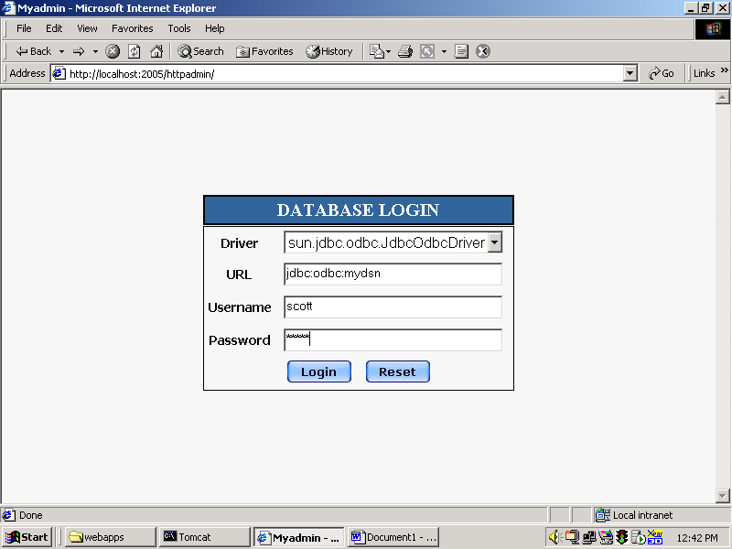

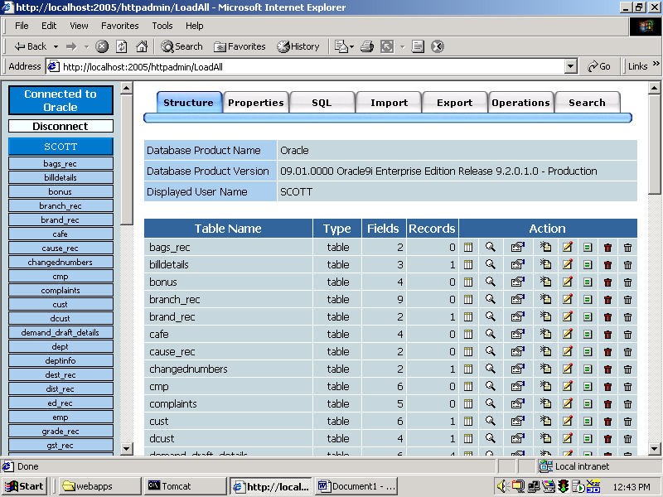

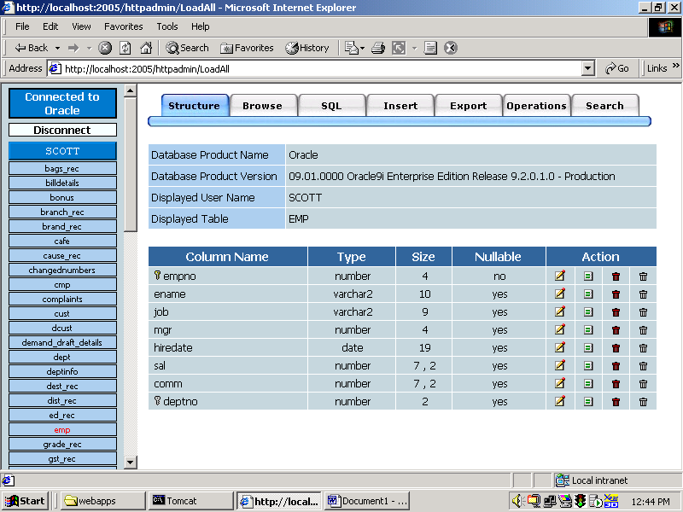

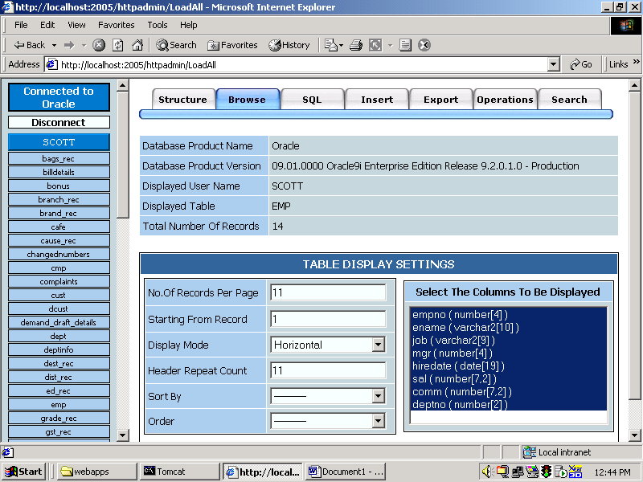

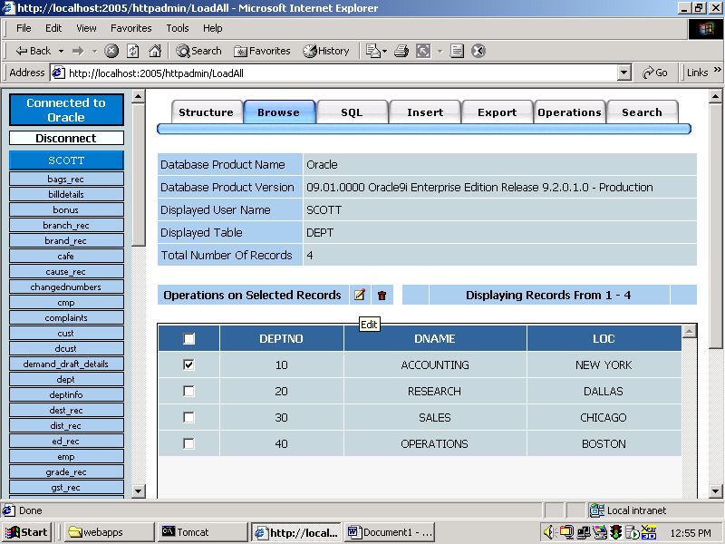

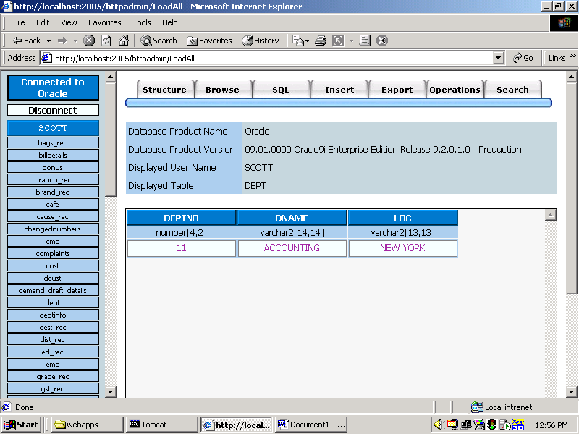

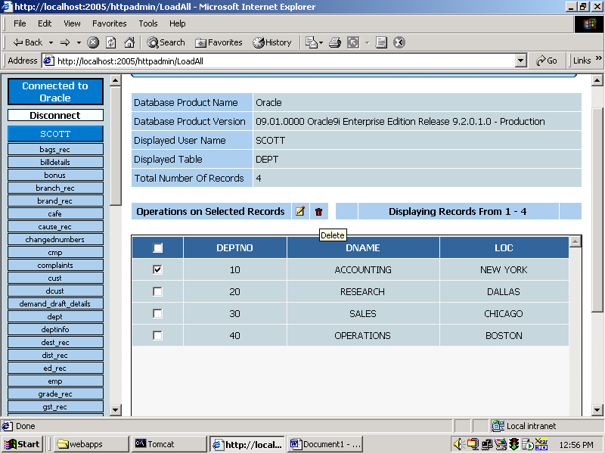

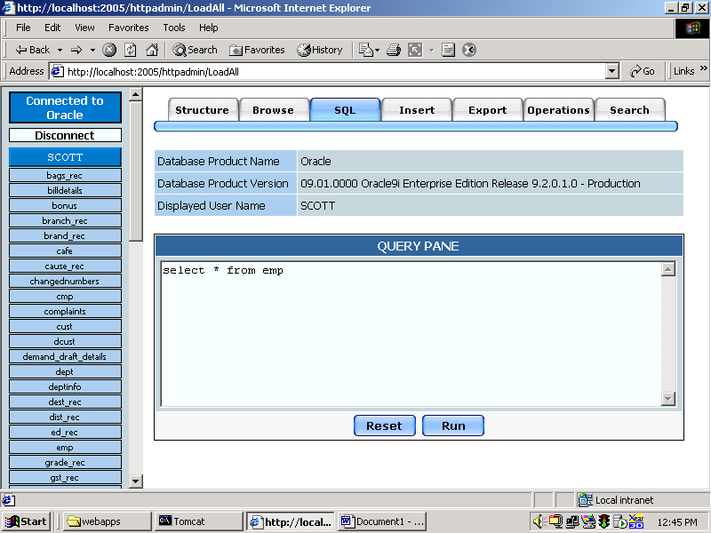

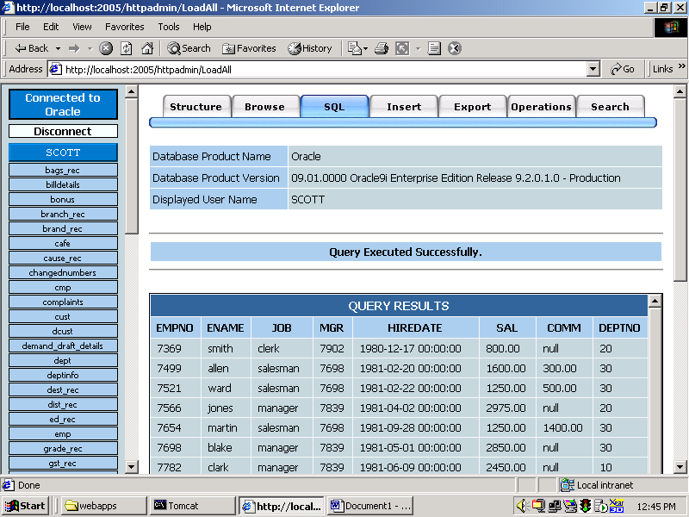

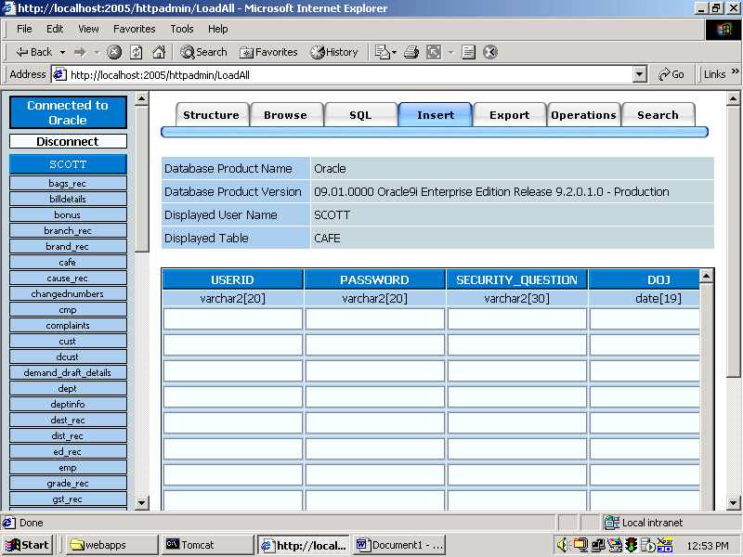

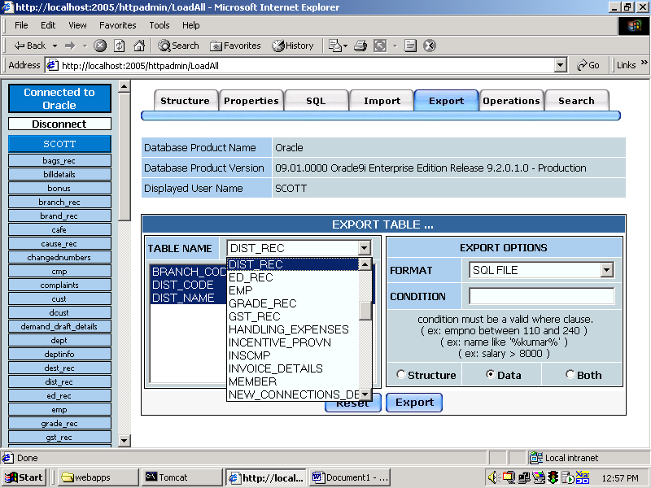

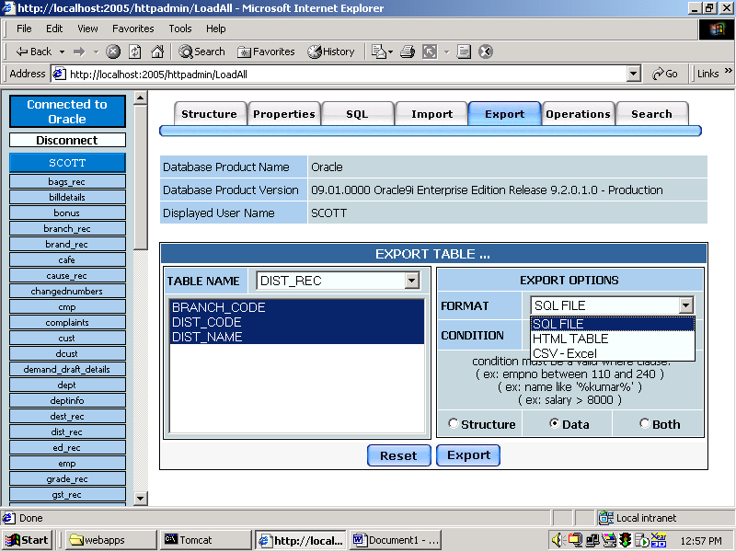

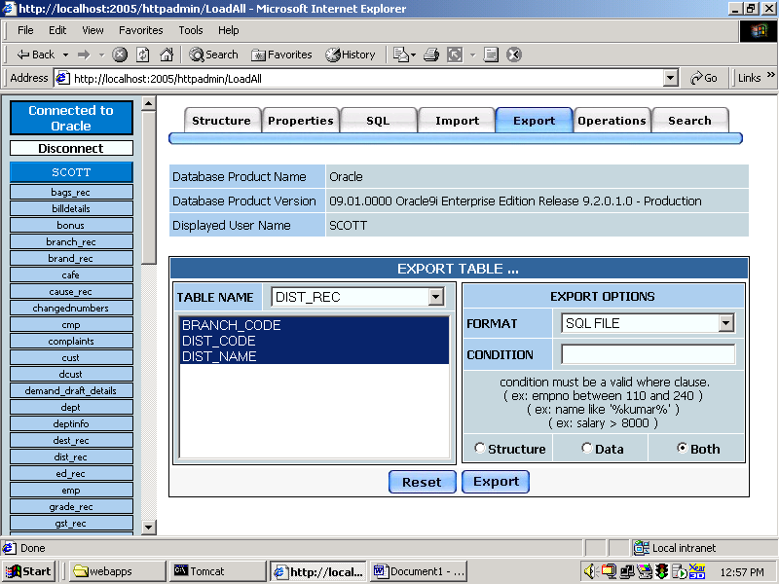

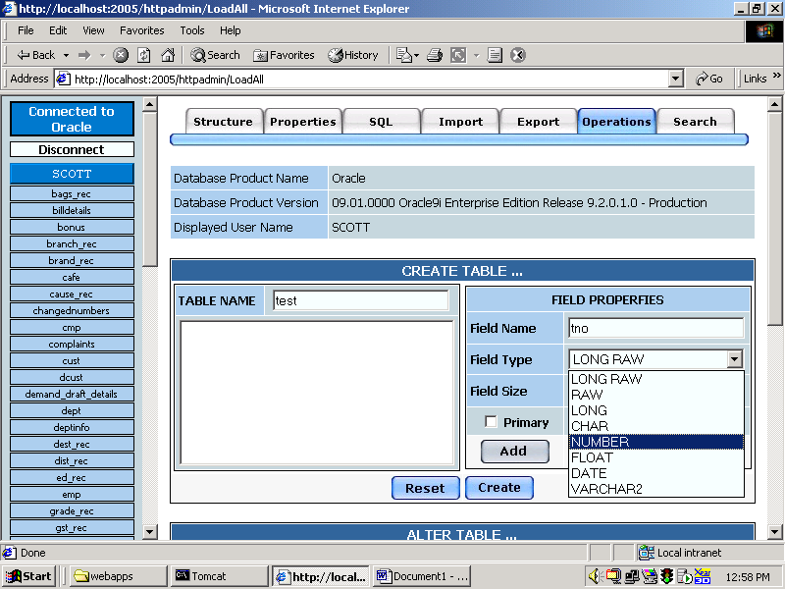

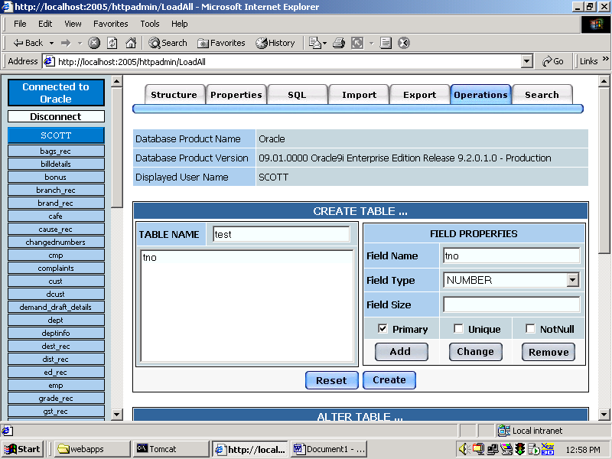

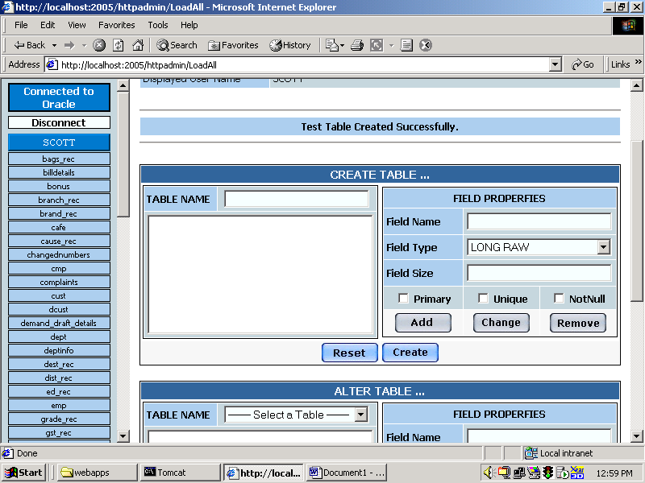

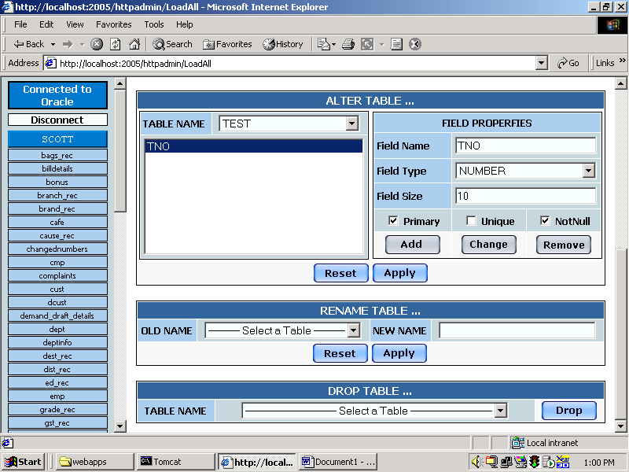

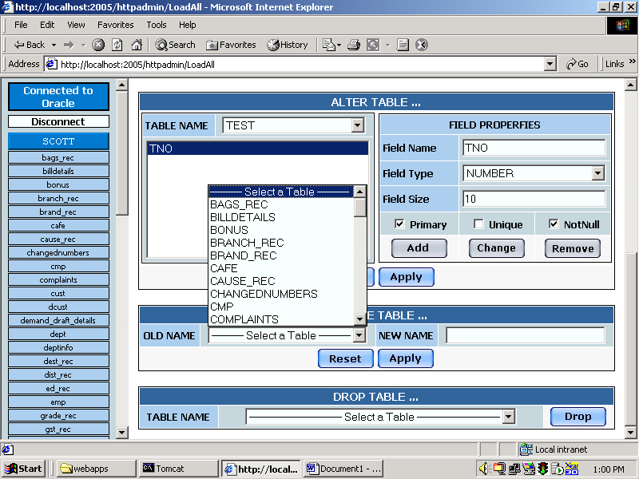

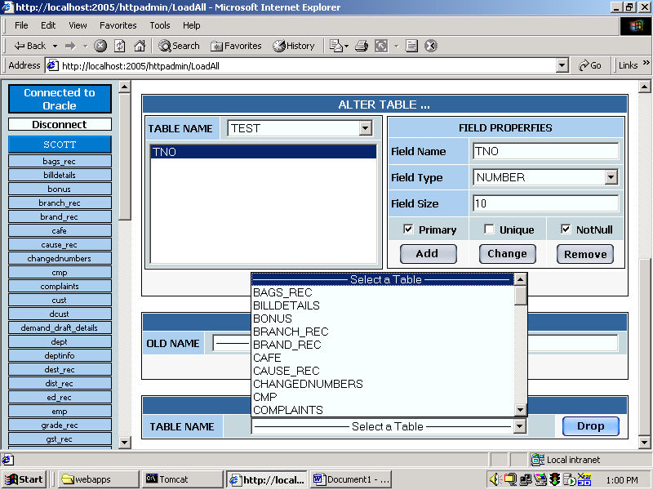

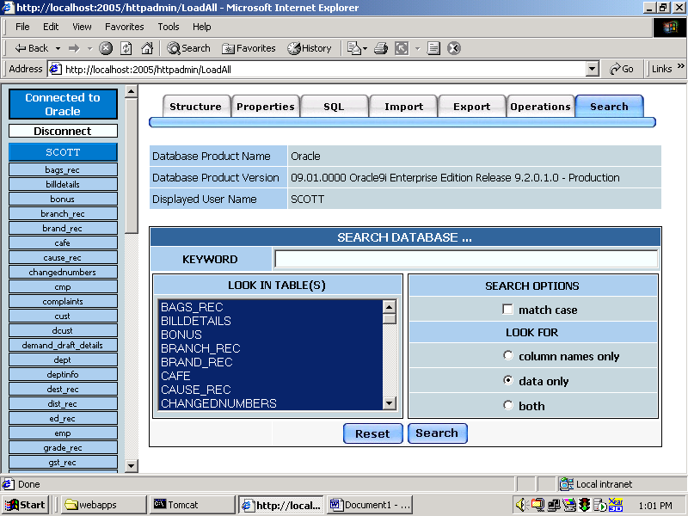

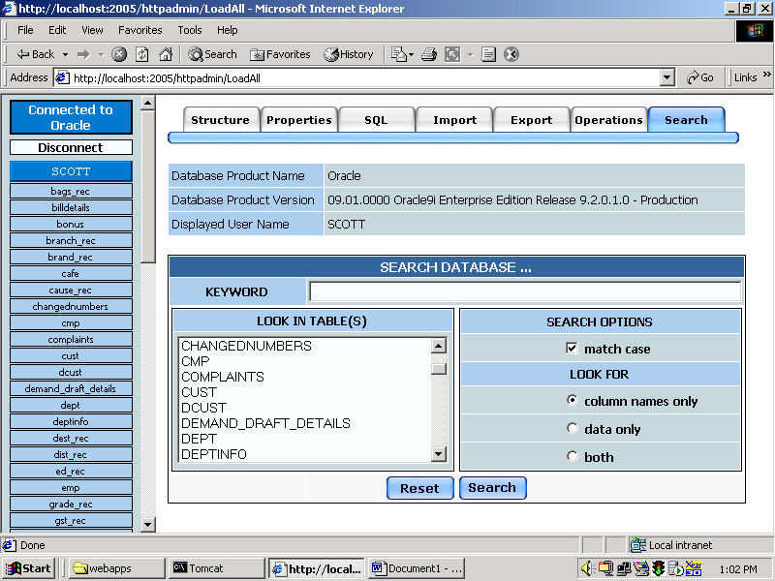

15. PERT CHART, GANTT CHART
PERT CHART:
Program Evaluation Review Technique, PERT can be both a cost and a time management system. PERT is organized by events and activities or tasks. PERT has several advantages over bar charts and is likely to be used with more complex projects. One advantage of PERT is that it is scheduling device that also shows graphically which tasks must be completed before others are begun.
Also, by displaying the various task paths, PERT enables the calculation of a critical path. Each path consists of combinations of tasks, which must be completed. PERT controls time and cost during the project and also facilitates finding the right balance between completing a project on time and completing it within the budget.

PERT CHART

25 JUN 2005

10 JUL 2005

START

ANALYSIS

I/O DESIGN
INTEGRATION AND TESTING

FINISH

WRITE MANUAL

CODING
01 JUL 2005
10 JUL 2005

10 JUL 2005
10 AUG 2005

15 AUG 2005

Gantt Chart ( Bar Chart ):

A Bar Chart is perhaps the simplest form of formal project management. The bar chart is also known as Gantt Chart. It is used almost exclusively for scheduling purposes and therefore controls only the time of projects.
Gantt Charts are a project control technique that can be used for several purposes, including scheduling, budgeting and resource planning. A Gantt Chart is a Bar Chart, with each bar representing an activity. The bars are drawn against a time line. The length of each bar is proportional to the length of time planned for the activity.

GANTT CHART

Jan 10, 06 Jan 20, 06 Feb10, 06 Feb 15, 06 Mar 01, 06

ANALYSIS
I /O DESIGN
CODING
WRITE MANUAL
INTEGRATION
AND
TESTING
TESTING

START

SLACK TIME, i.e., the LATEST TIME by which a task must be finished

White part of the bar shows the length of time each task is estimated to take

16. CONCLUSION
This application can be extended so that it will give maximum performance including the security related aspects, resulting releasing of this application as a product in the open market. As it has got very user friendly look and feel, it will be definitely succeeded in the market as a product.

17. BIBLIOGRAPHY

The Knowledge required for developing this project is extracted from the following books.

The Knowledge required for developing this project is extracted from the following books.

- The Java2 Complete Referece – By Patric Naughton
- Java2 Tutorial – From Sun Micro Systems
- Core Java2 Volume I – Fundamentals; SunSoft Press; S. Horstmann & Gary Cornell
- Core Java2 Volume II – Advanced Features SunSoft Press; S. Horstmann & Gary Cornell
- Professional Java Server Programming; Wrox publication; 12 Authors
- Java Foundation Classes; Orielly publications
- SYSTEM ANALYSIS AND DESIGN James A. Senn
- SOFTWARE ENGINEERING Roger S. Pressman

